**Analysis of the outputs from scheduling algorithms**

For the Scheduling algorithm code, the input and output formats are mentioned below.

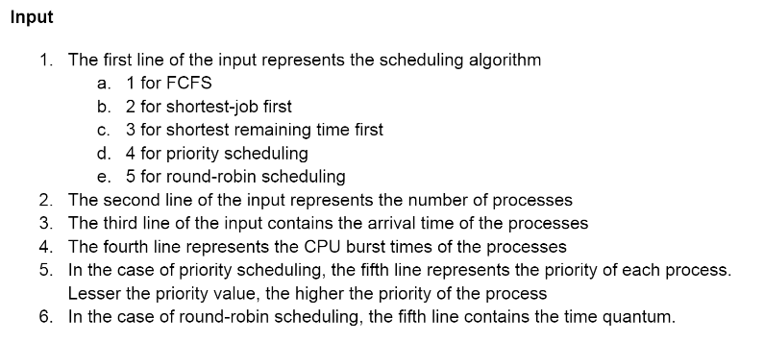

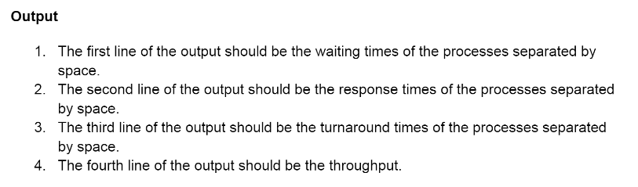

* **FCFS Output**

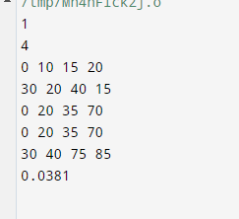

As we can see, the waiting and the response times are high for the processes or the patients in the above question. Therefore, this can’t be the ideal algorithm.

* **SJF Output**

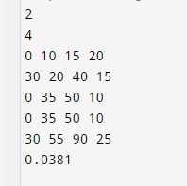

In the above results, we can see that the waiting times are better than FCFS, but it’s still not ideal in this case

* **PS Output**

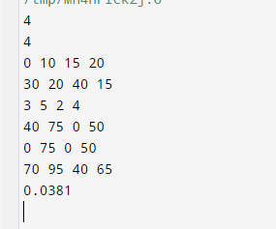

In the above results, we can see that priority scheduling performs better because the higher priority patients are to be given more importance than the lower priority ones. This algorithm would be the best in this question’s case.

**Priority Scheduling is the best**